Import Hachette Shipping Files

- Go to \\sierra\finance\2019\Warehouse, find the current period., e.g. 072017.
- Unzip the 21-CHONICLE BOOK_yyyymm.zip and 41-CHRONICLE DISTRIBUTION_yyyymm.zip. Both should unzip to CSV files.
- Go to \\sierra\Groups\VISTA\HachetteShipping, and launch ImportHBGShippingV2.exe.
- Click the “Get HBG Shipping Detail Report” button.

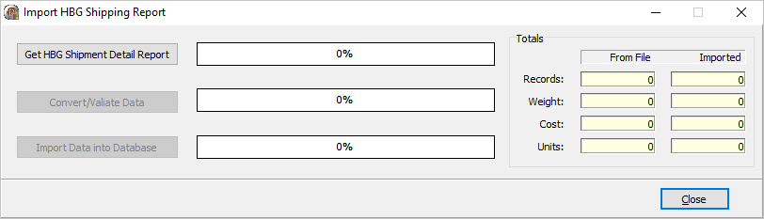
- Find the unzipped shipping files, e.g. 21-CHONICLE BOOK_yyyymm.csv and click “Open”.
There may be some invalid characters in the file. Typically, there should over 100,000 records in the file. The invalid characters will confuse the program into thinking there are only a few thousand records, or less.
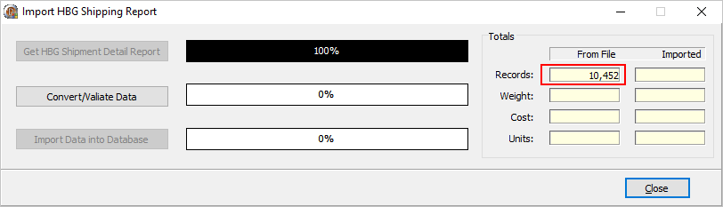
When this happens, you should open the csv file in Notepad++, find the invalid characters and remove them.

These invalid characters can be identified by going to the row marked by the Red box above. The number you see may be different however in this example it’s 10,452.

Copy the invalid character, and replace it with nothing. Highlight the character, “SUB”, CTRL+C (copy), CTRL+H (find and replace). Paste the character into the “Find what” box CTRL+V (paste) and delete anything in the “Replace with” box. The invalid character may look like a square;

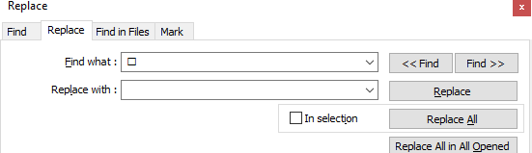

Click “Replace All” button, which may take a few seconds then save the file overwriting the original.

Close and re-open the “ImportHBGShippingV2.exe” program and re-open the saved file by clicking the “Get HBG Shipment Detail Report” button.

You should see something like this;
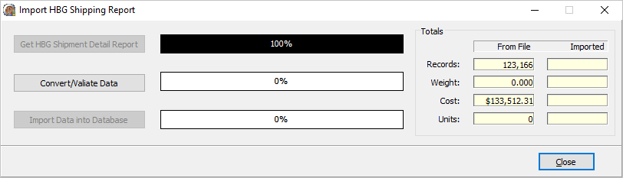
The file has Totals at the end of the file;
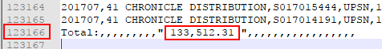
These numbers may not exactly match the numbers shown by ImportHBGShippingV2 but they should be close. I this example they do match.

- Click the “Convert/Validate Data” button. If there are any errors or messages, please contact Helpdesk.
- Click the “Import Data into Database” button, which may take a few minutes. Once completed, a dialog will be displayed;

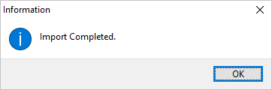

The files are renamed to .done once the process is completed.

